API Response Header

📬 What is an API Response Header
# Source: AI Source: Provided by: [Data Path: Persons Table -> ID Column: 1, Name_En Column: Motasem Essam] -> From: [ChatGPT] on [1/19/2026]
An API Response header is metadata sent by the API server along with the response. They provide metadata about the response, instructions for the client, or information about how the request was processed.
👉 Think of response headers as notes from the server to the client, explaining how to handle the response or giving additional context.

🔑 Common Response Headers
# Source: AI Source: Provided by: [Data Path: Persons Table -> ID Column: 1, Name_En Column: Motasem Essam] -> From: [ChatGPT] on [1/19/2026]
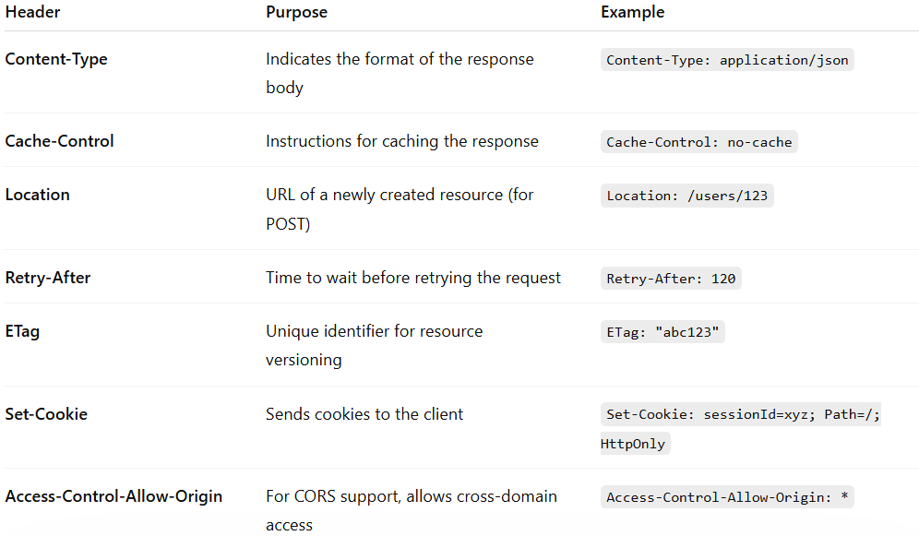
Header | Purpose | Example
Content-Type | Indicates the format of the response body | Content-Type: application/json
Cache-Control | Instructions for caching the response | Cache-Control: no-cache
Location | URL of a newly created resource (for POST) | Location: /users/123
Retry-After | Time to wait before retrying the request | Retry-After: 120
ETag | Unique identifier for resource versioning | ETag: "abc123"
Set-Cookie | Sends cookies to the client | Set-Cookie: sessionId=xyz; Path=/; HttpOnly
Access-Control-Allow-Origin | For CORS support, allows cross-domain access | Access-Control-Allow-Origin: *

🔑 1. Content-Type
# Source: AI Source: Provided by: [Data Path: Persons Table -> ID Column: 1, Name_En Column: Motasem Essam] -> From: [ChatGPT] on [1/19/2026]
- Purpose: Indicates the format of the response body so the client knows how to parse it.
- States / Variants:
  - Content-Type: application/json → JSON data (most common in REST APIs).
  - Content-Type: text/html → HTML content.
  - Content-Type: application/xml → XML data.
  - Content-Type: text/plain → Plain text response.
- Explanation: Tells the client how to interpret the response data.

🔑 2. Cache-Control
# Source: AI Source: Provided by: [Data Path: Persons Table -> ID Column: 1, Name_En Column: Motasem Essam] -> From: [ChatGPT] on [1/19/2026]
- Purpose: Provides instructions about how the response should be cached.
- States / Variants:
  - Cache-Control: no-cache → Must revalidate with server before using cached data.
  - Cache-Control: no-store → Don’t store response in cache at all.
  - Cache-Control: max-age=3600 → Cache is valid for 1 hour.
  - Cache-Control: private → Only cacheable by the client, not shared proxies.
- Explanation: Helps control caching behavior for performance and freshness.

🔑 3. Location
# Source: AI Source: Provided by: [Data Path: Persons Table -> ID Column: 1, Name_En Column: Motasem Essam] -> From: [ChatGPT] on [1/19/2026]
- Purpose: Indicates the URL of a newly created resource, usually returned after a POST request.
- States / Variants:
  - Location: /users/123 → Relative URL of new user.
  - Location: https://api.example.com/orders/456 → Absolute URL of new resource.
- Explanation: Tells the client where the new resource is located.

🔑 4. Retry-After
# Source: AI Source: Provided by: [Data Path: Persons Table -> ID Column: 1, Name_En Column: Motasem Essam] -> From: [ChatGPT] on [1/19/2026]
- Purpose: Tells the client how long to wait before retrying the request, often used with 429 Too Many Requests or 503 Service Unavailable.
- States / Variants:
  - Retry-After: 120 → Wait 120 seconds.
  - Retry-After: Wed, 30 Mar 2026 14:00:00 GMT → Wait until a specific date/time.
- Explanation: Helps clients avoid spamming the server during overload or rate-limiting.

🔑 5. ETag
# Source: AI Source: Provided by: [Data Path: Persons Table -> ID Column: 1, Name_En Column: Motasem Essam] -> From: [ChatGPT] on [1/19/2026]
- Purpose: Provides a unique identifier for the resource version, used for caching and conditional requests.
- States / Variants:
  - ETag: "abc123" → Simple string identifier.
  - ETag: W/"xyz789" → Weak ETag, indicates minor changes may not invalidate cache.
- Explanation: Allows the client to check if a resource has changed without downloading it again (If-None-Match requests).

🔑 6. Set-Cookie
# Source: AI Source: Provided by: [Data Path: Persons Table -> ID Column: 1, Name_En Column: Motasem Essam] -> From: [ChatGPT] on [1/19/2026]
- Purpose: Sends cookies from the server to the client, often for session management.
- States / Variants:
  - Set-Cookie: sessionId=xyz; Path=/; HttpOnly → Standard session cookie.
  - Set-Cookie: theme=dark; Secure; SameSite=Strict → Cookie with security attributes.
  - Set-Cookie: lang=en-US; Expires=Wed, 30 Mar 2026 23:59:59 GMT → Cookie with expiration.
- Explanation: Used to store stateful information on the client side.

🔑 7. Access-Control-Allow-Origin
# Source: AI Source: Provided by: [Data Path: Persons Table -> ID Column: 1, Name_En Column: Motasem Essam] -> From: [ChatGPT] on [1/19/2026]
- Purpose: Part of CORS (Cross-Origin Resource Sharing). It tells the browser which domains are allowed to access the response.
- States / Variants:
  - Access-Control-Allow-Origin: * → Any domain can access.
  - Access-Control-Allow-Origin: https://example.com → Only example.com can access.
  - Not present → Cross-origin requests may be blocked by the browser.
- Explanation: Enables safe cross-domain requests, preventing unauthorized access.

🧱 Example: Response Headers
# Source: AI Source: Provided by: [Data Path: Persons Table -> ID Column: 1, Name_En Column: Motasem Essam] -> From: [ChatGPT] on [1/19/2026]
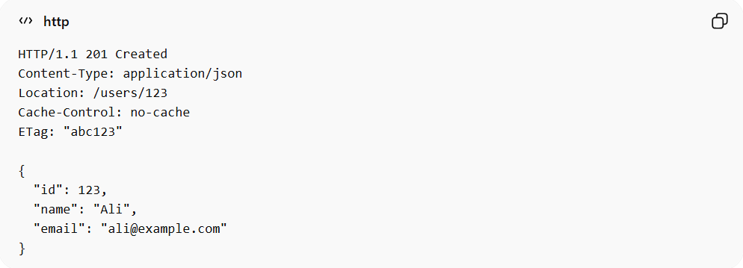
HTTP/1.1 201 Created
Content-Type: application/json
Location: /users/123
Cache-Control: no-cache
ETag: "abc123"

{
"id": 123,
"name": "Ali",
"email": "ali@example.com"
}
✅ Here:
- Content-Type → response format is JSON
- Location → points to newly created user resource
- Cache-Control → instructs client not to cache response
- ETag → identifies this version of the resource

❌ Common Mistakes
# Source: AI Source: Provided by: [Data Path: Persons Table -> ID Column: 1, Name_En Column: Motasem Essam] -> From: [ChatGPT] on [1/19/2026]
- Omitting Content-Type, leaving clients unsure how to parse response ❌
- Using inconsistent headers across endpoints ❌
- Exposing sensitive information in headers ❌

💡 Summary
# Source: AI Source: Provided by: [Data Path: Persons Table -> ID Column: 1, Name_En Column: Motasem Essam] -> From: [ChatGPT] on [1/19/2026]
Response headers provide context, metadata, and instructions about the API response, helping clients process it correctly.

